QUESTION : 1
Write an SQL query to display the total number of songs uploaded by each artist from a table 'songs' (columns: song_id, artist_name, title) and show only those artists who have uploaded more than 3 songs :

TABLE songs :
CREATE TABLE songs(
song_id INT,
artist_name VARCHAR(100),
title VARCHAR(100),
PRIMARY KEY(song_id)
);

INSERT INTO songs(song_id, artist_name, title)
VALUES
(1,'Arijit','Kesariya'),
(2,'Arijit','Apna Bana Le'),
(3,'Arijit','Tum Hi Ho'),
(4,'Arijit','Chaleya'),
(5,'Neha','Kala Chashma'),
(6,'Neha','Coca Cola'),
(7,'Darshan','Asal Mein'),
(8,'Darshan','Baarish'),
(9,'Darshan','Hawa Banke'),
(10,'Darshan','Tera Zikr');

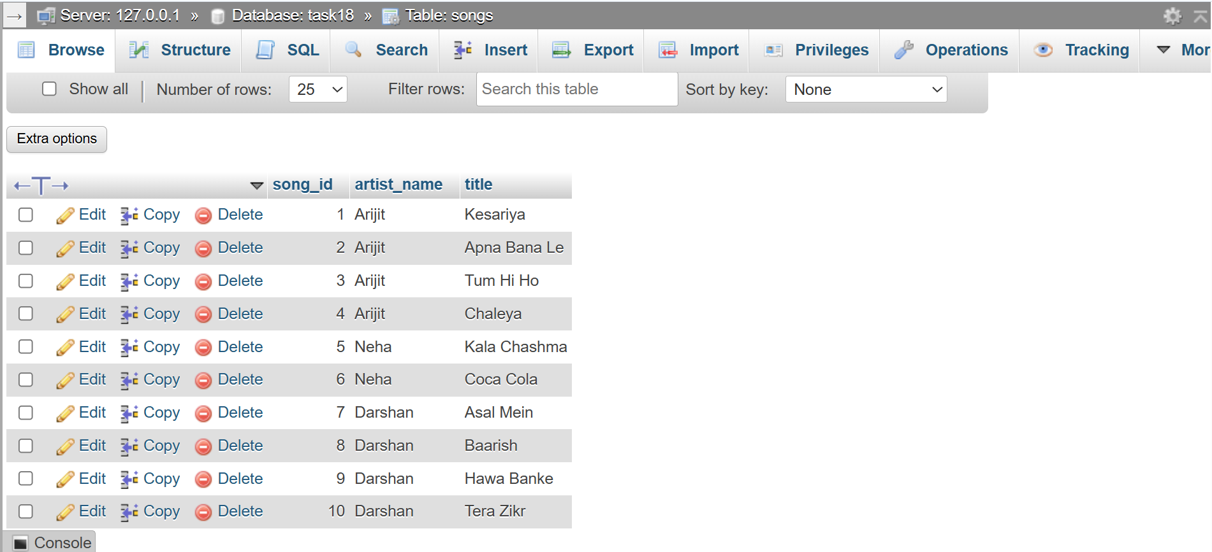
SELECT artist_name,COUNT(song_id) AS total_songs
FROM songs
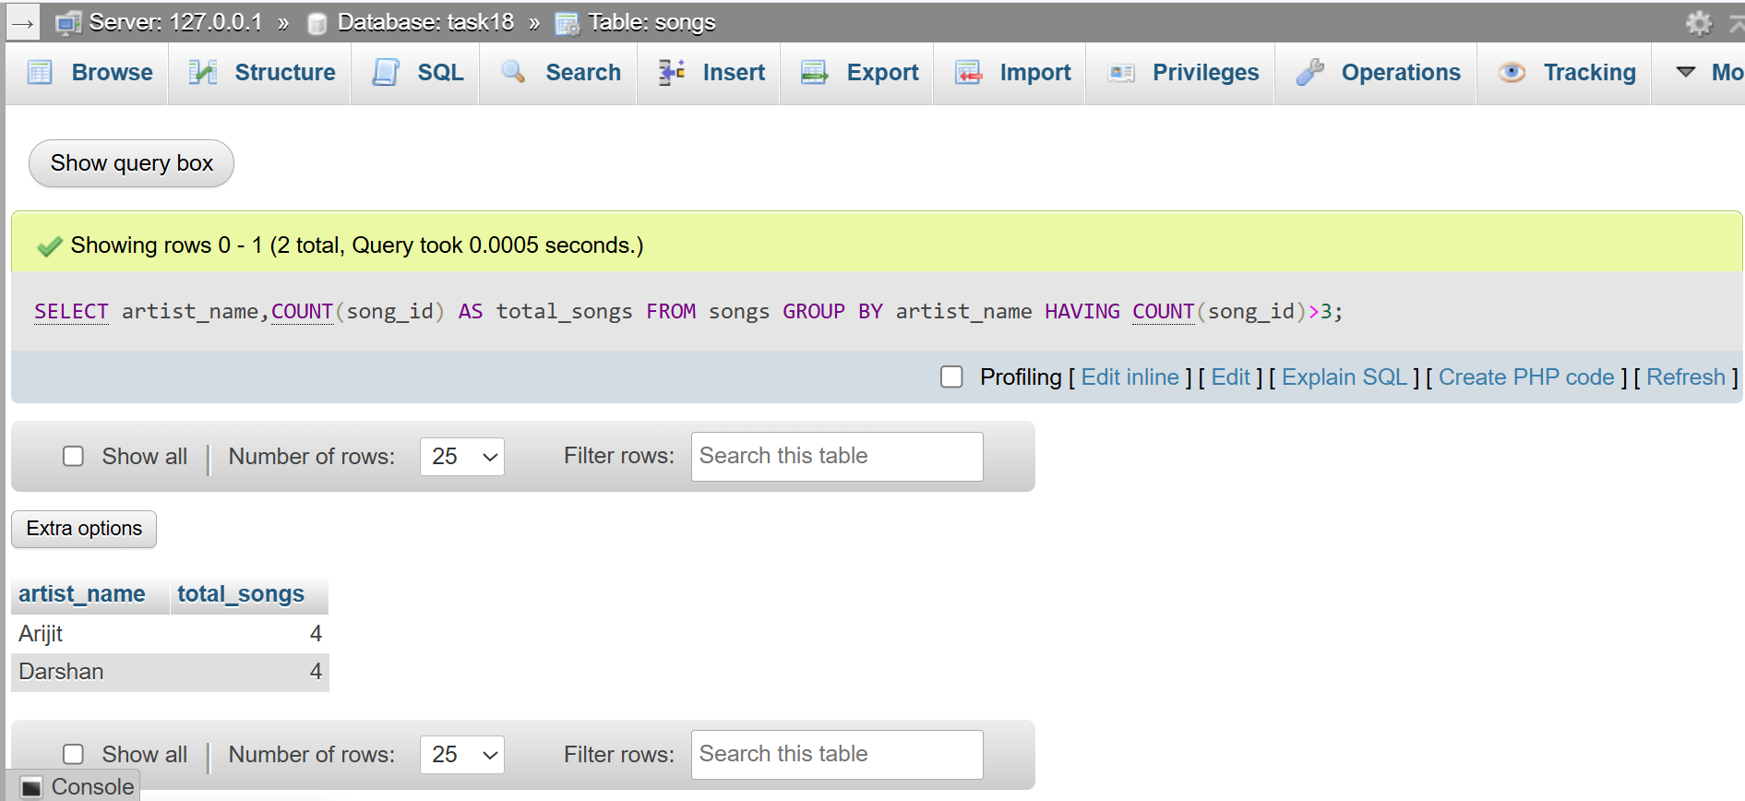
GROUP BY artist_name HAVING COUNT(song_id)>3 ;
QUESTION : 2
Given two tables, 'orders' (order_id, user_id, amount) and 'users' (user_id, username), write a SQL JOIN query to display each username along with their total order amount :
TABLE users :
CREATE TABLE users(
user_id INT,
username VARCHAR(100),
PRIMARY KEY(user_id)
);
INSERT INTO users(user_id,username)
VALUES (1,'Vivek'),(2,'Rahul'),(3,'Priya');

TABLE orders :
CREATE TABLE orders(
order_id INT,
user_id INT,
amount INT,
PRIMARY KEY(order_id)
);

INSERT INTO orders(order_id,user_id,amount)
VALUES
(101,1,500),
(102,1,800),
(103,2,1200),
(104,2,400),
(105,3,700);
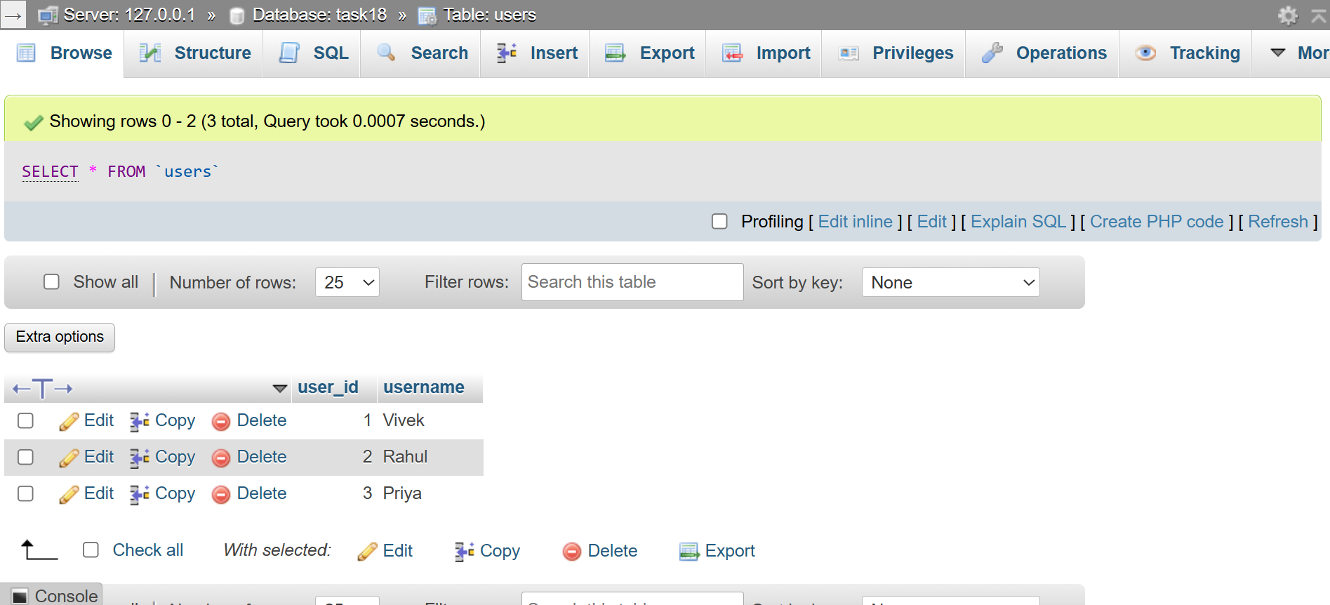
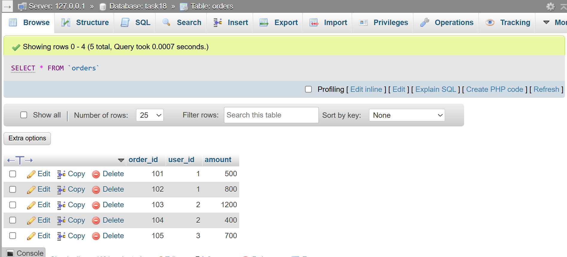
SELECT u.username,SUM(o.amount) AS total_order_amount FROM users AS u
JOIN orders AS o ON u.user_id=o.user_id
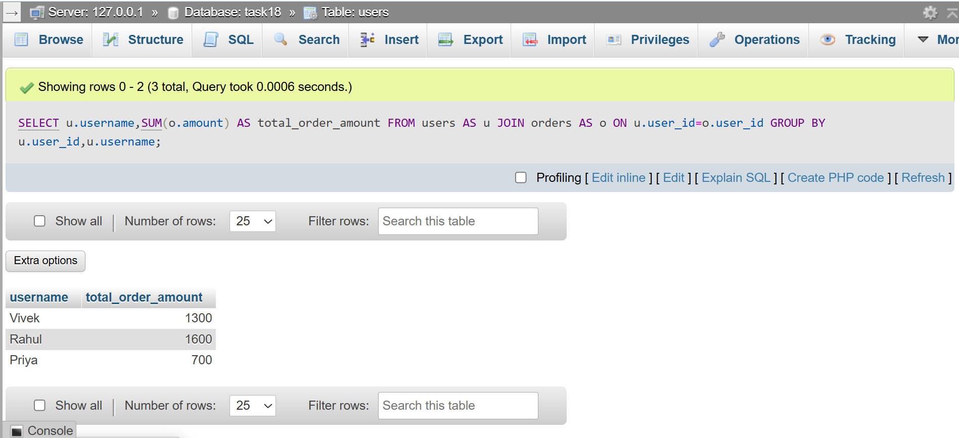
GROUP BY u.user_id,u.username;
QUESTION : 3
Write a SQL subquery to find the names of all restaurants from a 'restaurants' table (id, name, rating) whose rating is higher than the average rating of all restaurants :
TABLE restaurants :
CREATE TABLE restaurants(
id INT,
name VARCHAR(100),
rating DECIMAL(2,1),
PRIMARY KEY(id)
);
INSERT INTO restaurants(id,name,rating)
VALUES
(1,'Dominos',4.5),
(2,'McDonalds',4.2),
(3,'La Pinoz',4.8),
(4,'Subway',4.1),
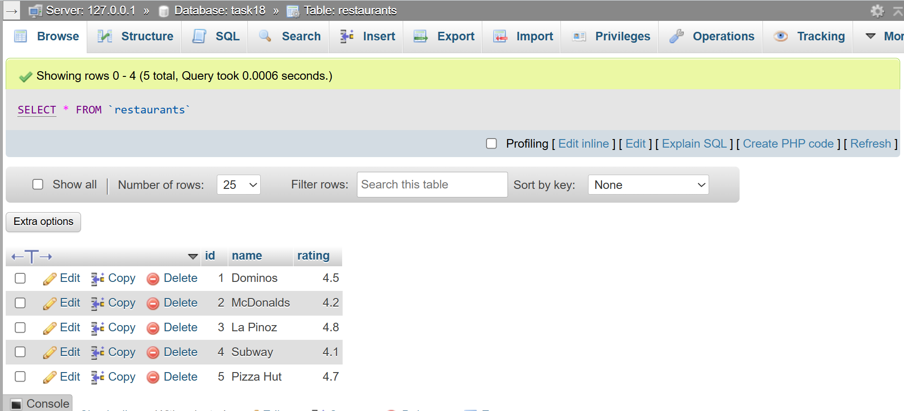
(5,'Pizza Hut',4.7);

SELECT name FROM restaurants
WHERE rating>
(SELECT AVG(rating)FROM restaurants);

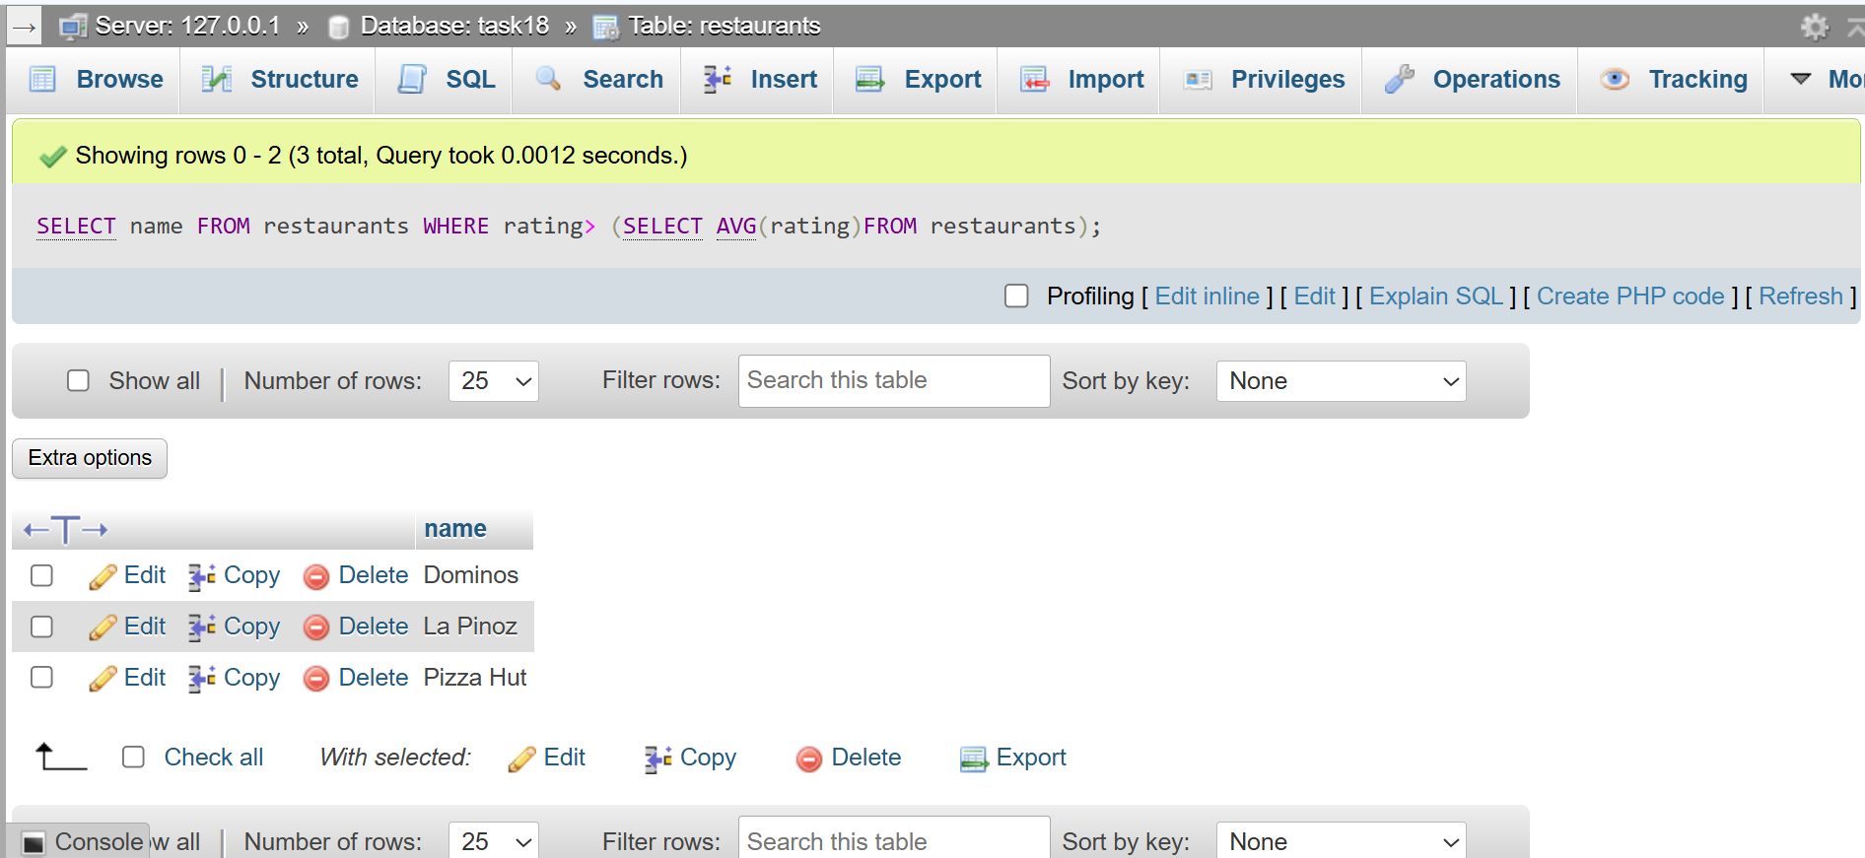
QUESTION : 4
Using a 'transactions' table (id, user_id, amount, transaction_date), write a SQL query with a window function to display each user's transaction amount and their running total (cumulative sum) ordered by transaction_date :

TABLE transactions :
CREATE TABLE transactions(
id INT,
user_id INT,
amount INT,
transaction_date DATE,
PRIMARY KEY(id)
);
INSERT INTO transactions(id,user_id,amount,transaction_date)
VALUES
(1,101,500,'2026-07-01'),
(2,101,300,'2026-07-03'),
(3,101,400,'2026-07-05'),
(4,102,700,'2026-07-01'),
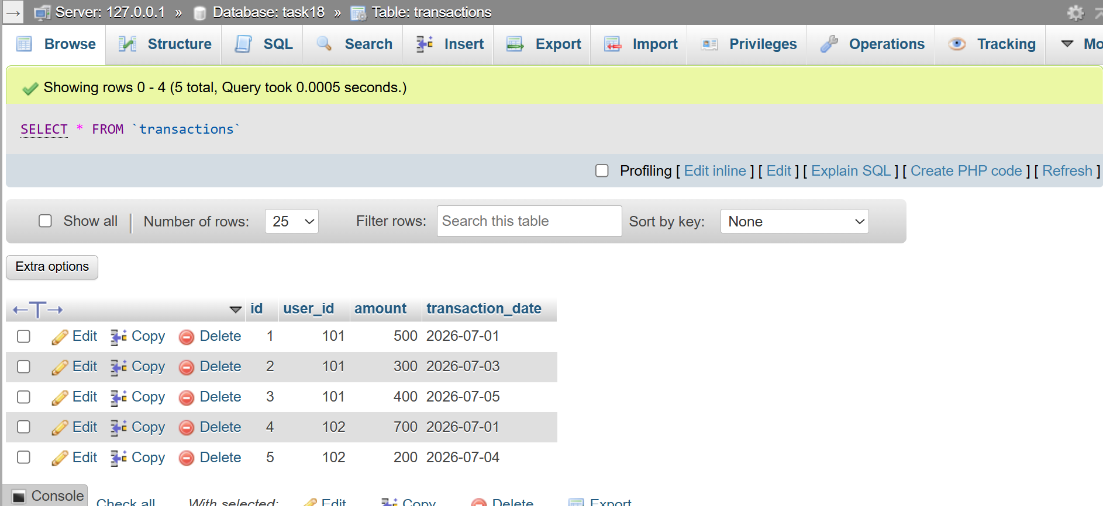
(5,102,200,'2026-07-04');

SELECT user_id,transaction_date,amount,
SUM(amount) OVER(PARTITION BY user_id ORDER BY transaction_date) AS running_total
FROM transactions;
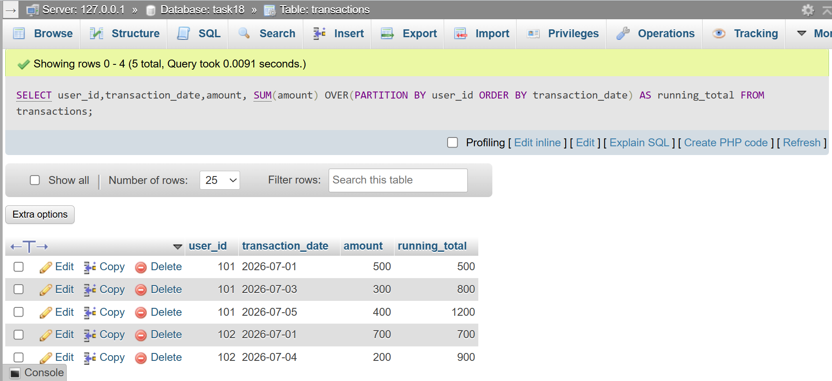
QUESTION : 5
List two optimizations you would apply to speed up a query that filters Flipkart products by category and price, and briefly explain how each helps.<br><br><em><strong>Hint:</strong> Think about indexes and query structure</em>:

Create an Index on category and price :
Creating an index on the category and price columns helps the database find matching products much faster. Instead of scanning every row in the table, the database uses the index to directly locate the required records…..

Use an Efficient Query Structure :
I would use a proper WHERE clause and select only the required columns instead of using SELECT *. Retrieving only the necessary rows and columns reduces the amount of data processed by the database. This makes the query faster, uses fewer system resources, and improves overall performance…..

